Link to GitHub repo: https://github.com/eterrius/inf1103-labs

Mount and run screenshot:
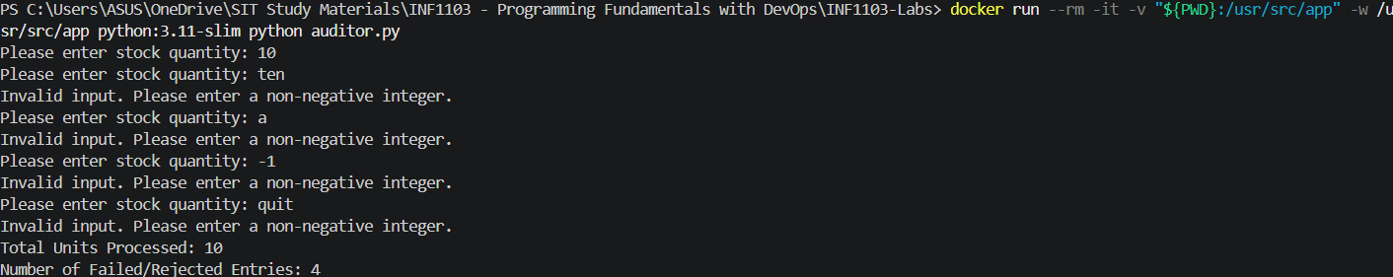

Image built successfully:
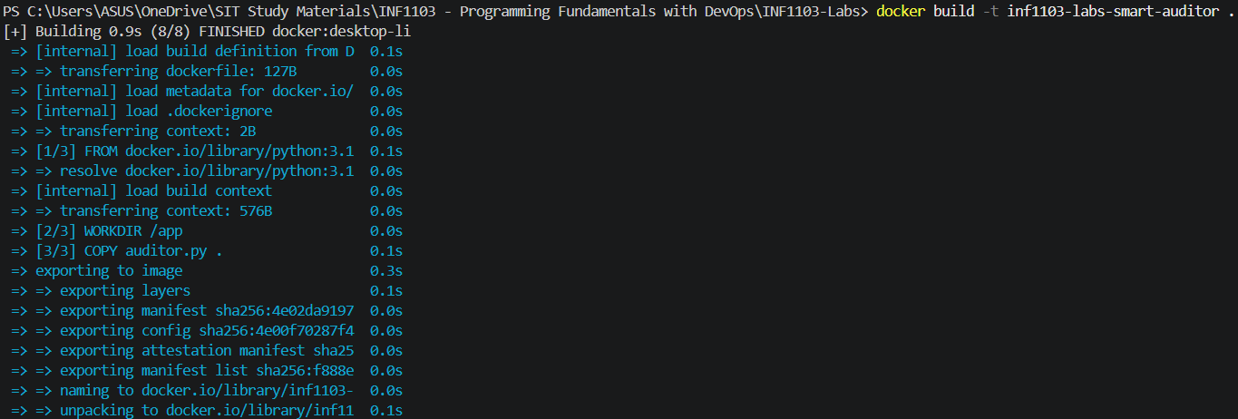

Docker images:

Image runs successfully:
